PWA Tutorial Notes

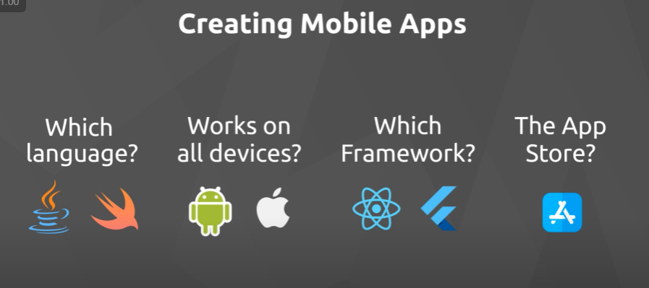

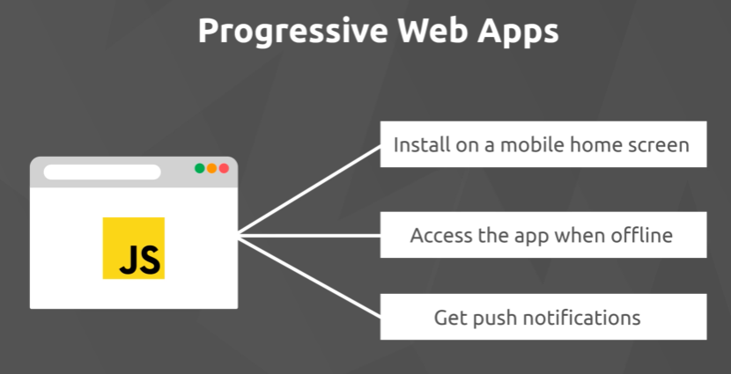

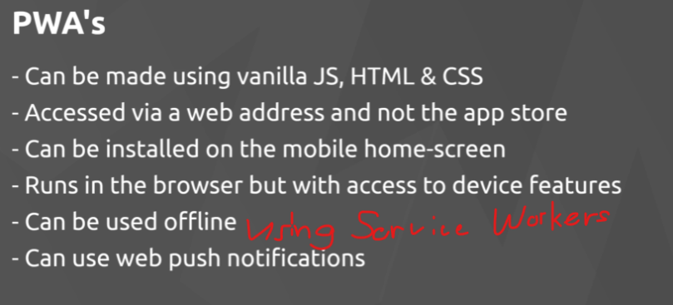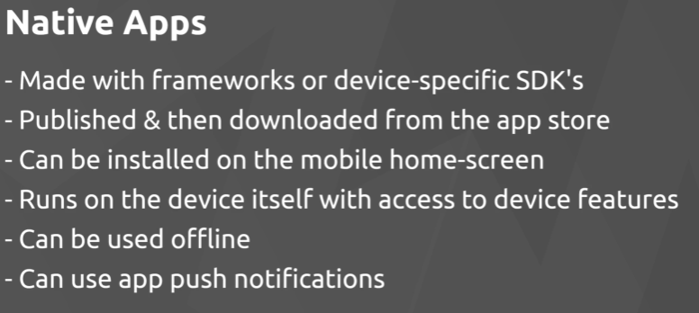

Offline Data Persistence can be achieved trough Firebase Database  
Future Playlist 🡪 Firebase messaging and push notifications

## Ein Bild, das Text, Screenshot, Software, Multimedia-Software enthält. KI-generierte Inhalte können fehlerhaft sein.**Das Web-App-Manifest**

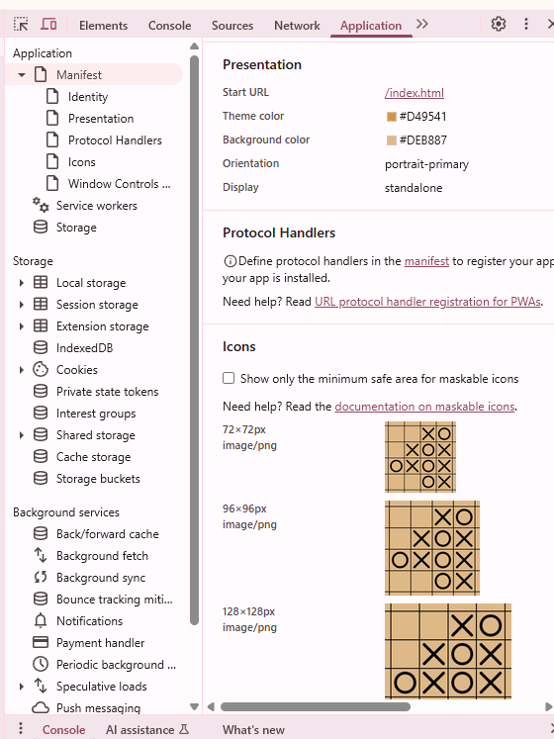

## **Service Workers**

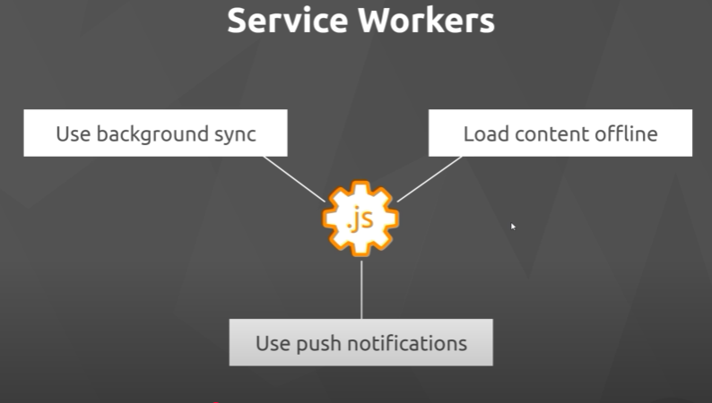

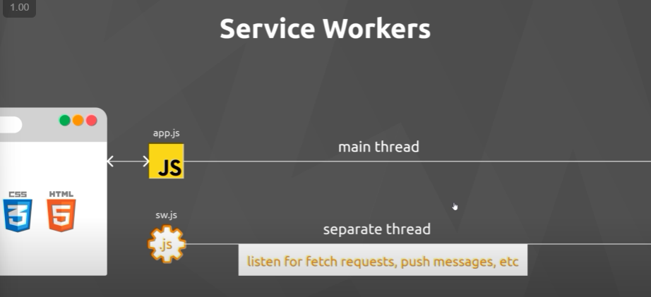

Service Workers can also listen for Lifecycle Events

1. 1. Step when creating a service worker is to register it with the browser (we do this form a normal js file not from the service worker file itself)
2. This is what tells then the browser that the js file sw.js should be registered a service worker and put to that separate service worker thread.
3. Then the browser fires the install event, inside sw.js we can then listen and react for this event! (for example we could do asset caching so that we can use them when the user is offline)
4. The Install event fires only once if the sw.js has not been changed. 🡪 when the service worker is registered.
5. After the service is installed it becomes active and the browser then fires an active event!
6. We might also listen and react to this active event inside sw.js
7. Once the service worker is active, it can access all the different files inside it’s scope (place it in the root directory to have access to all project files)
8. At this point the service worker can listen to fetch requests, push messages etc.
9. When we reload/refresh the page the service worker is still registered
10. The service worker gets then only reinstalled if some code inside the service worker file has been changed since the last time it was installed in the browser (even if it’s just comments)
11. So whe we reload the page and there have been no changes made to the service worker code in the meantime, it will not reinstall it.
12. Say sw.js has been changed and the browser installs it newly, then the service worker would not become active by itself (it only becomes active by itself the first time it is installed!). The old service worker will stay active by default. The new service worker will be in a waiting stage.
13. The new service worker is only gonna become active after all of our instances of our app are closed. (all tabs or the app itself on mobiles)

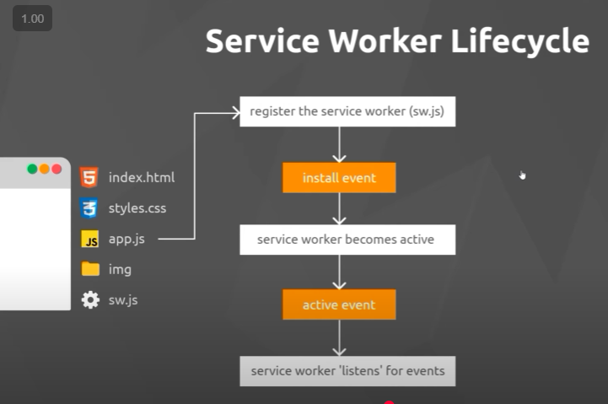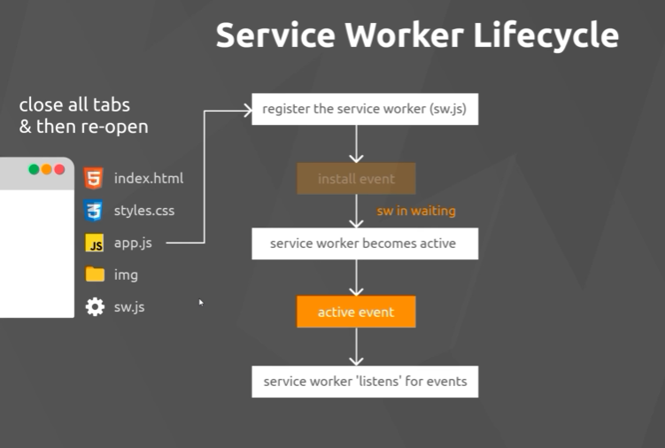

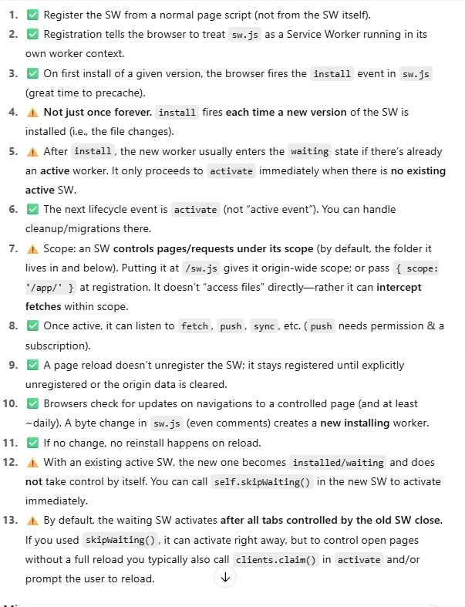

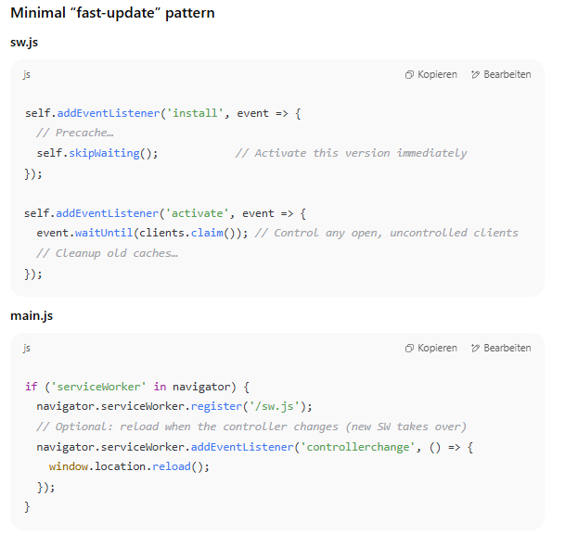

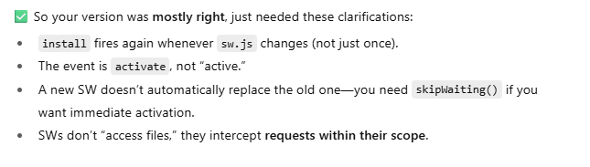

## **Registering Service Workers**

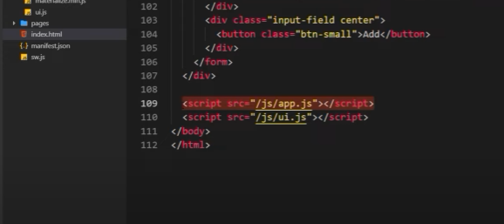

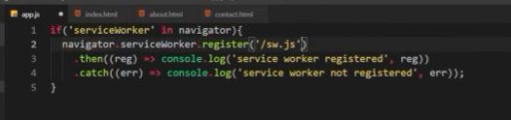

When the promise is resolved (successful) then it fires the callback functions inside the then method otherwise it fires the callback function inside the catch method.

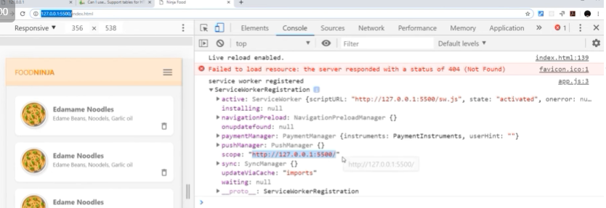

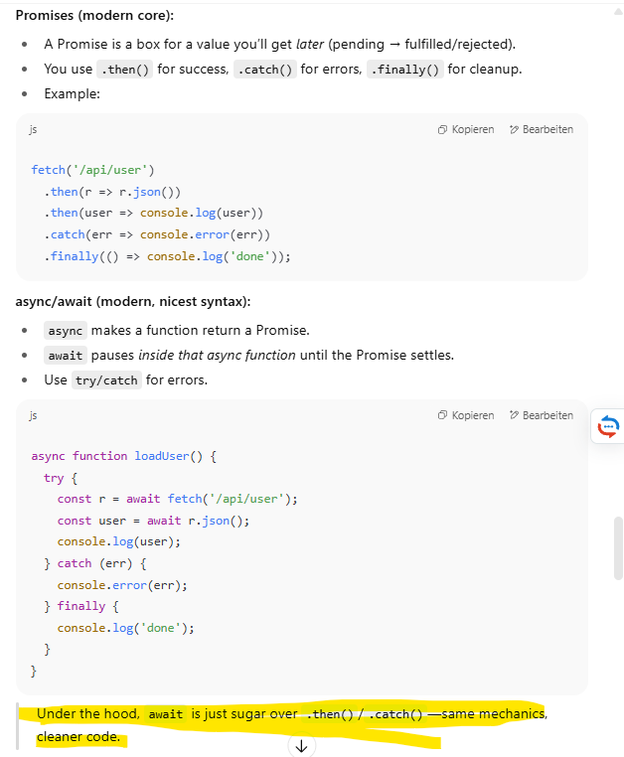

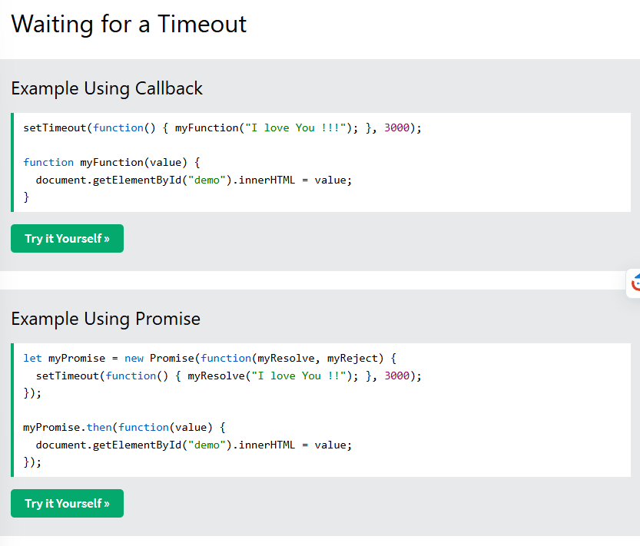

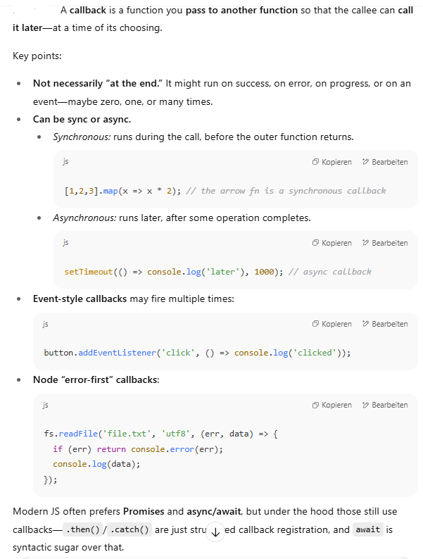

## Ein Bild, das Text, Screenshot, Schrift, Software enthält. KI-generierte Inhalte können fehlerhaft sein.**The Install Event**

Now we listen to the Install Event (i.e when the service worker gets installed to the browser) 🡪 we do that by adding an event listener in sw.js file itself.

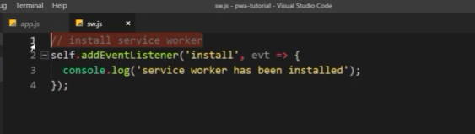

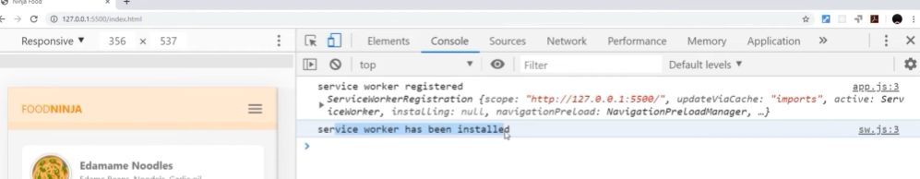

Event tough through changing sw.js, the new service worker has been installed it is not activated as we can see in the application tab. It only gets activated when we close all of the tabs and then reopen the application.  
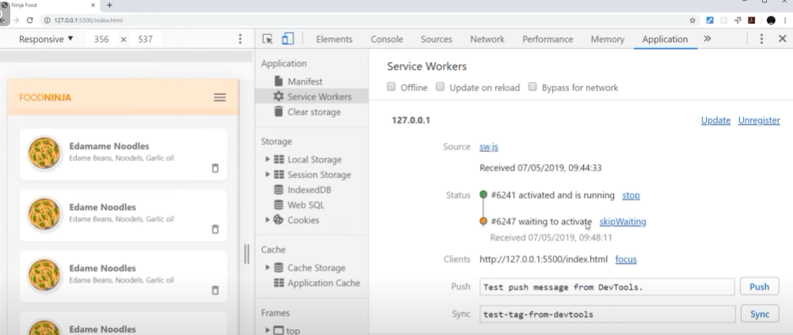

## Ein Bild, das Text, Screenshot, Software, Multimedia-Software enthält. KI-generierte Inhalte können fehlerhaft sein.**The activate event**

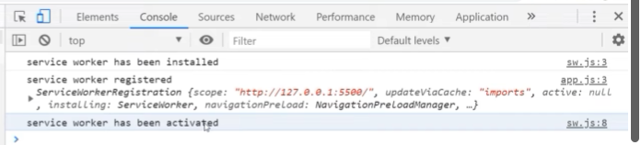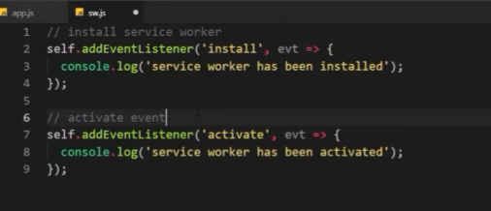 If there is no service worker there, the installed service worker automatically becomes active.

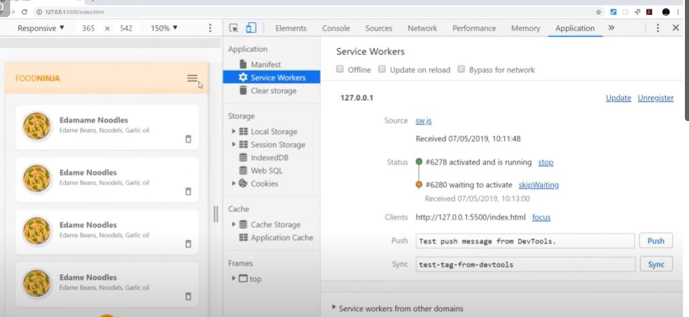If we have a new service worker it will only become active after closing and reopening all sites related to the application.

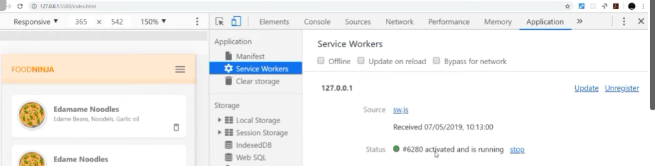After reopening:

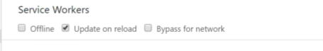Update on reload so that we as engineers don’t have to close and reopen applications while coding:

## **Installation criteria**

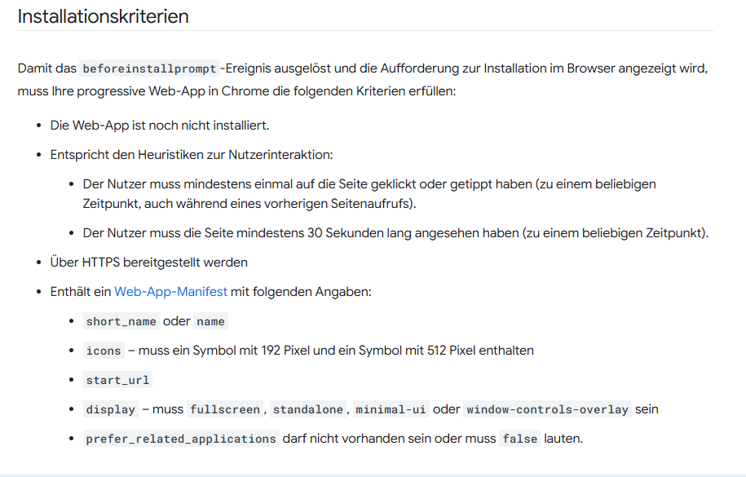

## **Fetch Events**

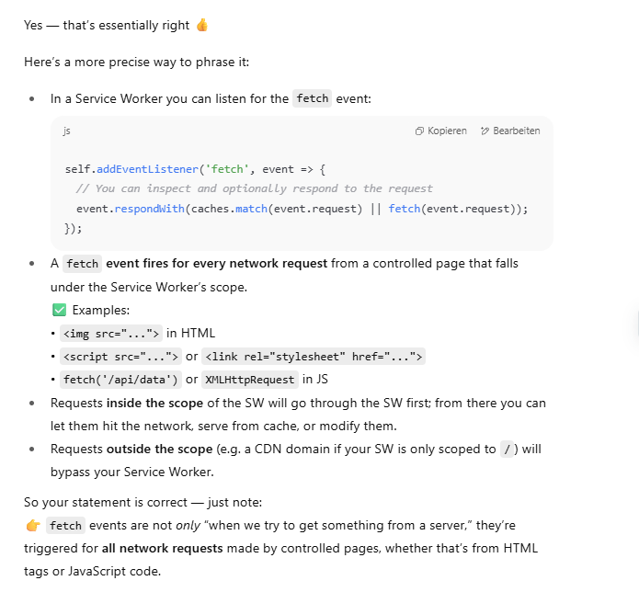Next to events like install and activate in sw.js there are also fetch events. Fetch events occur whenever we try to get something from a server. Could be files referenced to in html tags or from a js file if we would make some http requests.

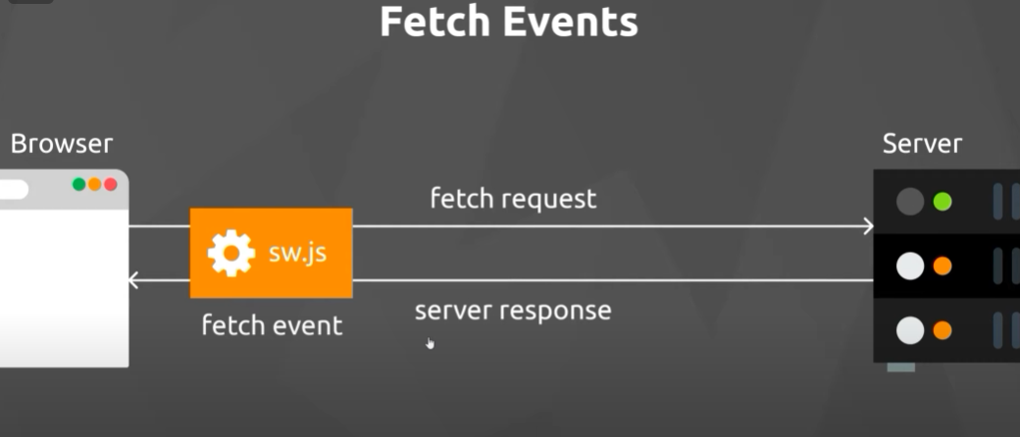

Question: why would we want to intercept requests at all?  
Answer: Our Serveice Worker will eventually be handling cached assets and at some point when a fetch request is made from the browser, we might want to stop that request so that it gets whatever it requested from the cache instead of the server. **IMPORTANT**

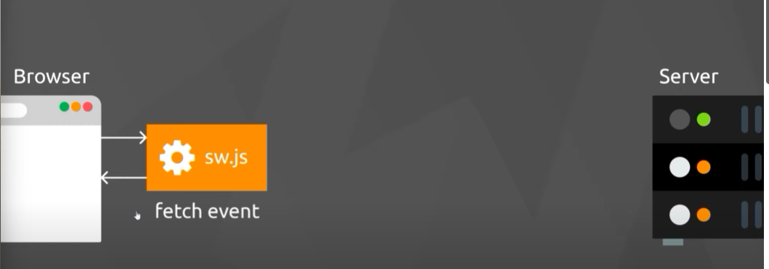

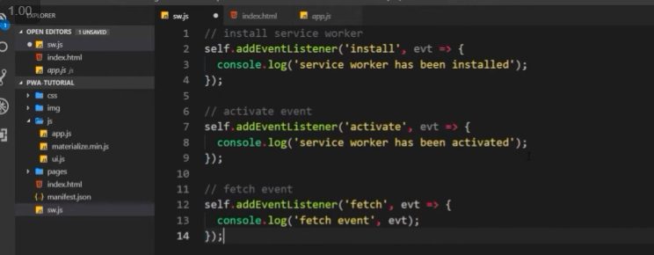

Logs all fetch events:  
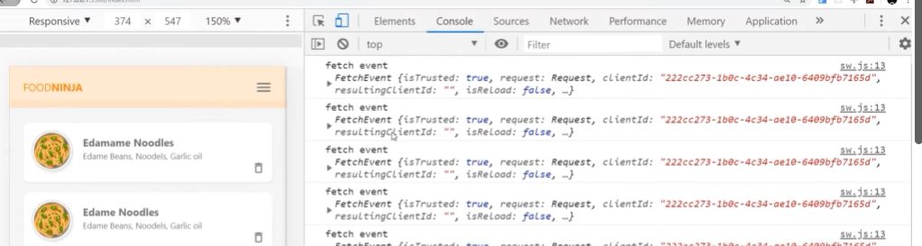

## **Offline Mode explained**

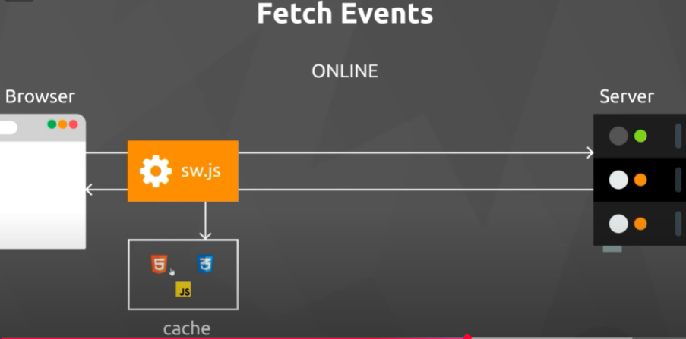The key is to cache assets which just means storing assets locally.

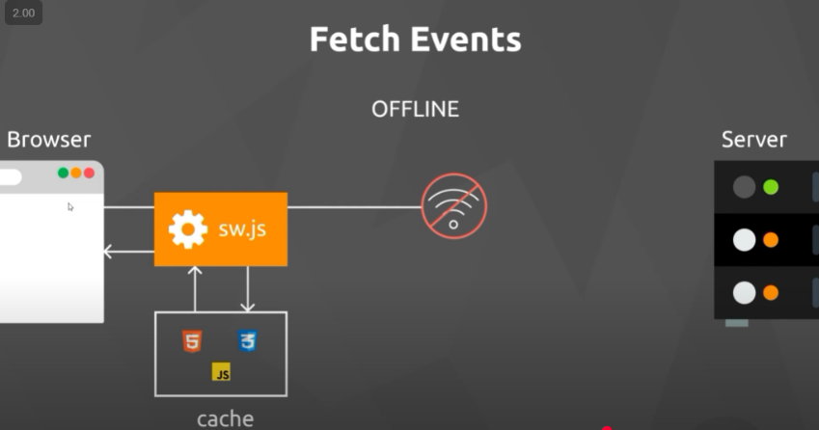

## **Precaching of assets**

We should be cashing static assets like logo, core html and core css, any images that we use quite a lot – basically just assets that don’t change much over time. Never cache the sw.js itself!

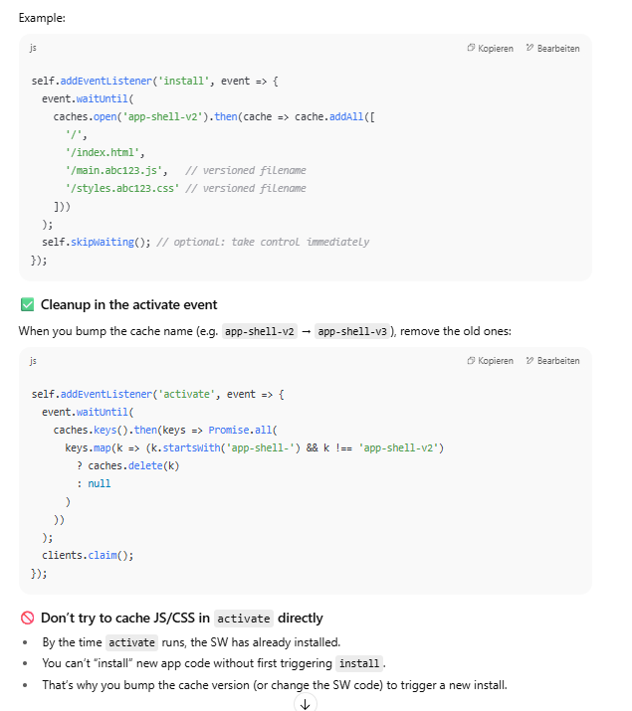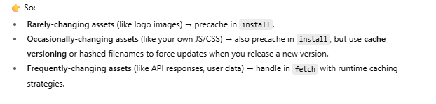

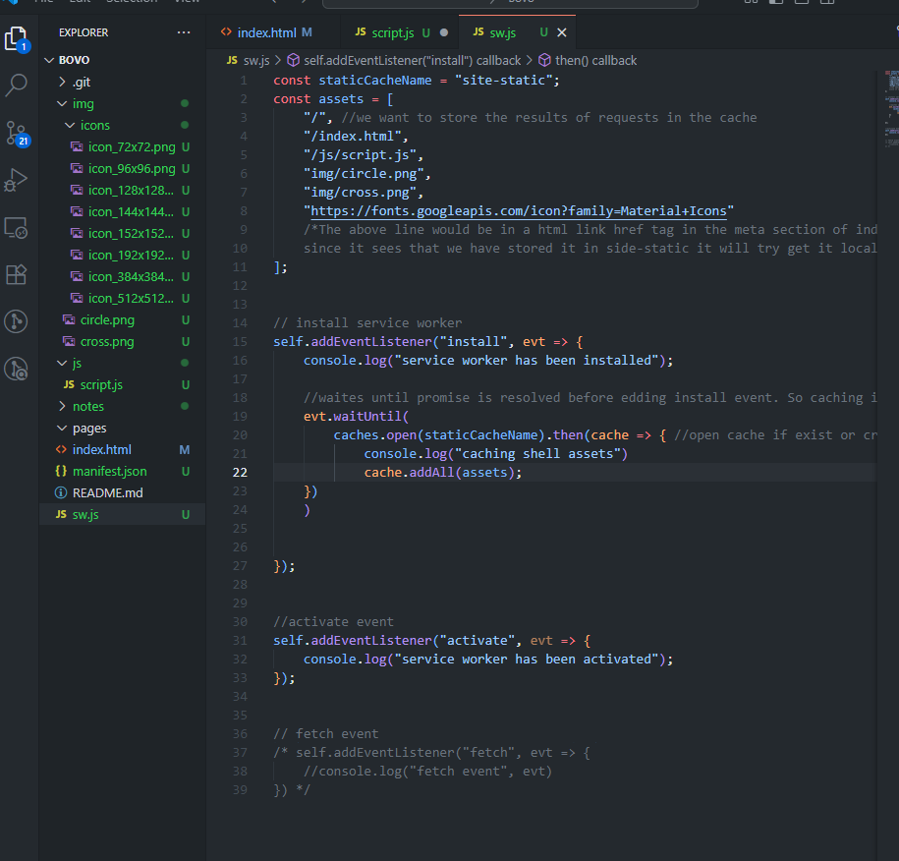

## **Zwischengespeicherte Assets abrufen**

We need to intercept any intercepts for assets or ressources and check if those requests match a key in our cache. If they match we need to pause the fetch to the server and return the asset/resource in the cache instead!

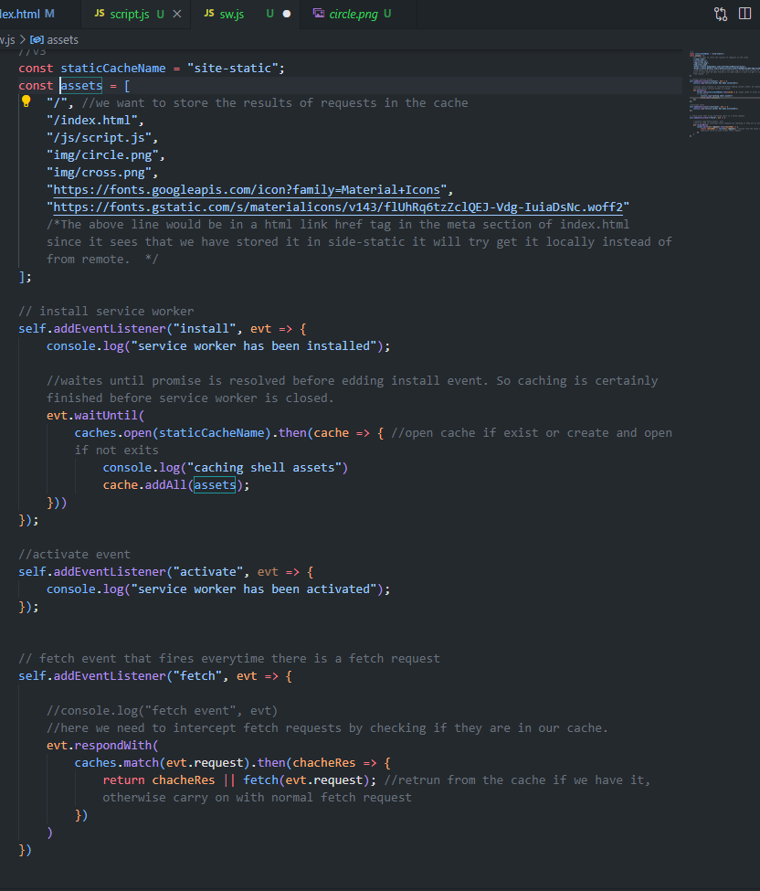

## **Cache Versioning**

(since users don’t have update on reload checked on service workers)

What if we updated assets/ressources that are in the cache?   
The service worker will still show the old version in the cache and not the new version.

So the intall event needs to refires and therefore if we change chached assets we need to change the sw.js as well.

Solution: change cache name and add a version part

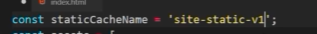

Now we have two caches but it will still load from the old cache even after reloading the page. Because it doesn’t now what cache to use for fetch requests, we need to delete the old cache in the activate event.  
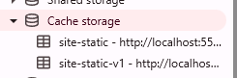

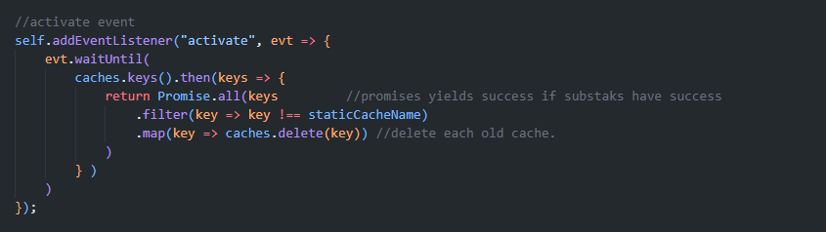

now each time we make changes to our cached assets we need to update staticCacheName var to another version and then we see there is only one active cache and our site is up do date.

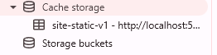

## **Dynamic Caching**

For big pages we don’t want to cache everything in the install event.   
Just maybe the index.html page and core assets (app shell assets).   
For other sites it makes sense to cache them only when the user has visited those side sites and we create an other cache for this!



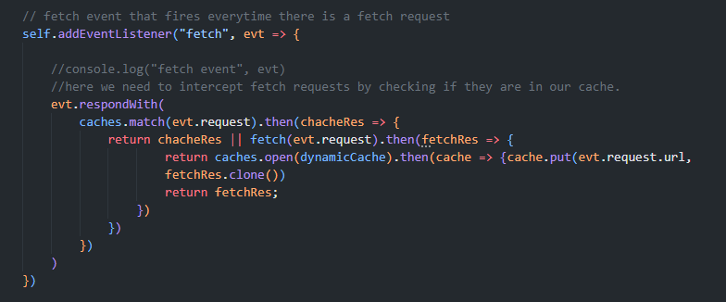

Currently we’re also clearing dynamic cache if we activate a new service-worker.

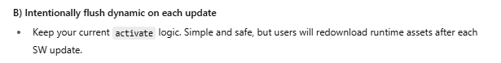

If we want to keep dynamic cache:

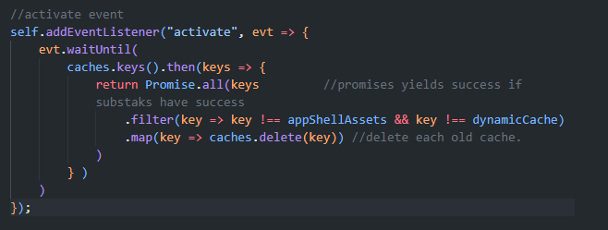

If we don’t want it to be delete

## **Offline Fallback-site**

Sbow User fall back site instead of horrible error message.

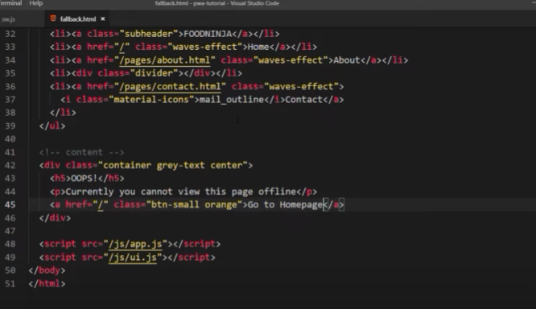

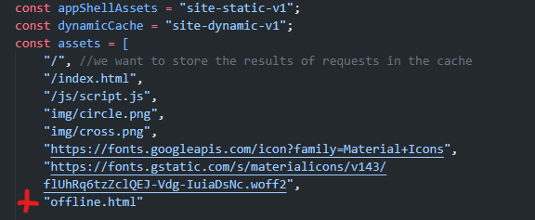

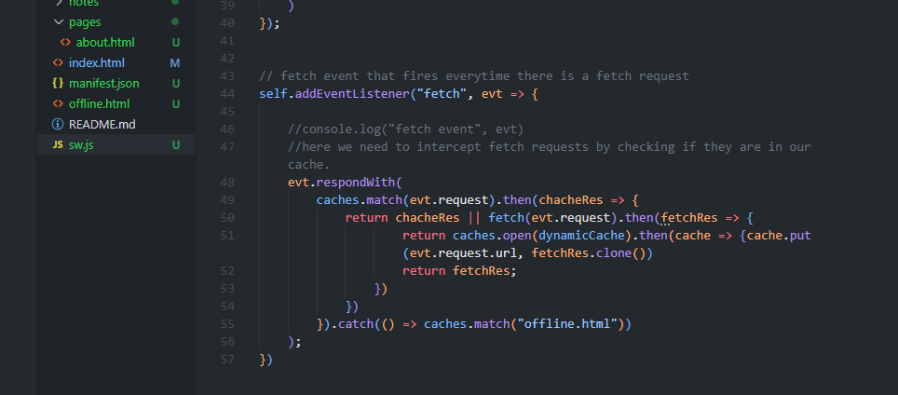

Now if the user has never been on the about.html, goes then offline and then clicks on about.html this will occur:  
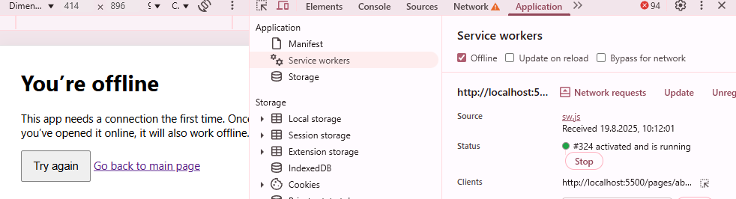

## **Conditionally using Cache**

Currently we’re serving the offline.html to the user everytime he is offline and makes a fetch request to something that is not saved in our cache. That makes no sense for images, css, etc but it makes sense for html pages and actual website routes.  
So we need to make a little check before we return that fallback page!

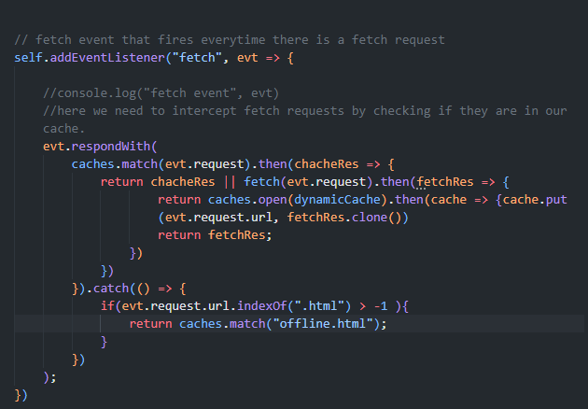

**Note**: we could to other check like indexOf(“.png”) ant then return a dummy image for this case.

There are many different cache strategies, here’s an overview:  
https://web.dev/articles/offline-cookbook?hl=de

## **Limiting the Cache Size**

Currently we cache everything that is not already cached. At some point our cache is become very big and become a drain on ressources.  
Solution approach: limit caches to hold a max number of items, if that number is reached, remove oldest item to add a new item…

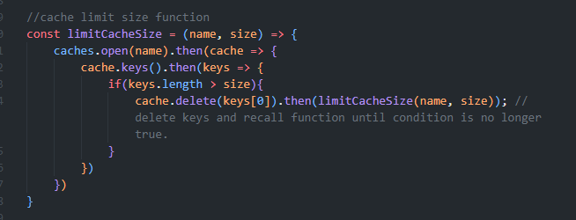

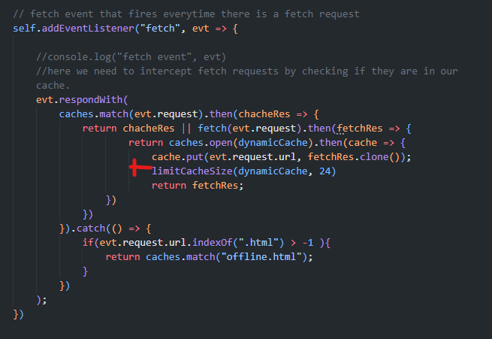

## **Firebase Database (currently out of my project scope)**

This needs to be updated very often since Data is changed frequently.  
(We don’t want show users old data)

Google Fire Base is a bunch of different services which act as a backend to our application.

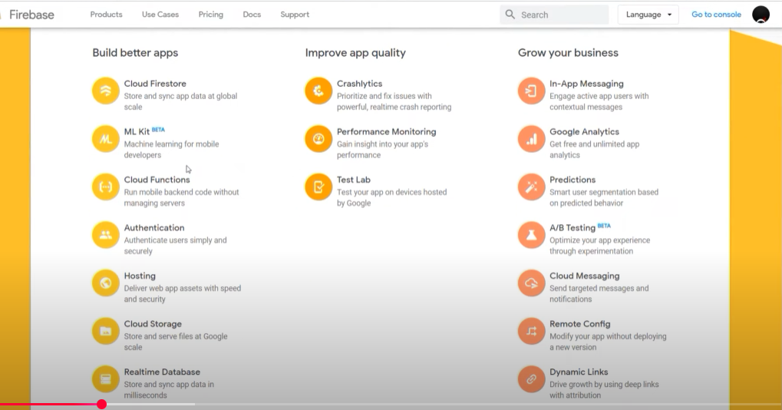

+ Stripe payment

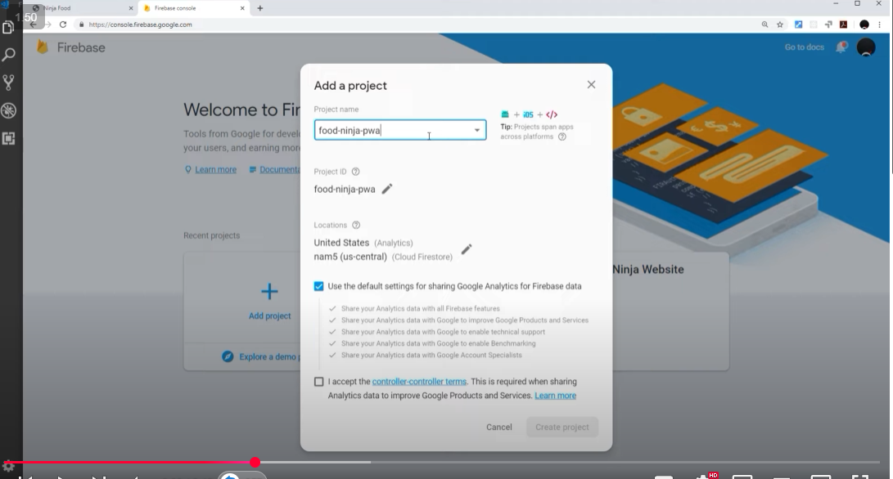

Firebase Firestore Playlist - [ • Firebase Firestore Tutorial #1 - Introduction](https://www.youtube.com/watch?v=4d-gIPGzmK4&list=PL4cUxeGkcC9itfjle0ji1xOZ2cjRGY_WB&index=1)

Firebase Authentifizierungs-Tutorial - [ • Firebase Authentication Tutorial #1 - Intr...](https://www.youtube.com/watch?v=aN1LnNq4z54&list=PL4cUxeGkcC9jUPIes_B8vRjn1_GaplOPQ&index=1&pp=0gcJCR0AztywvtLA)

1. Create Cloud Firestore Database

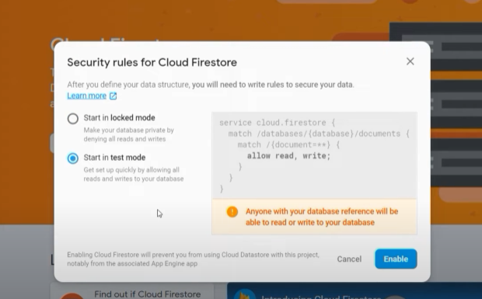

For dev choose test mode but before publishing the app switch to locked mode!

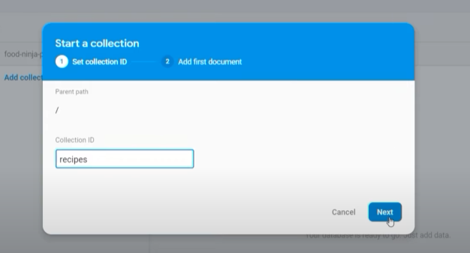

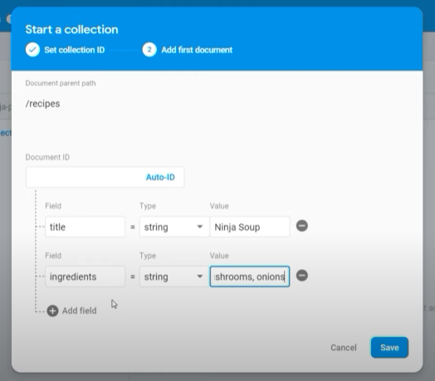

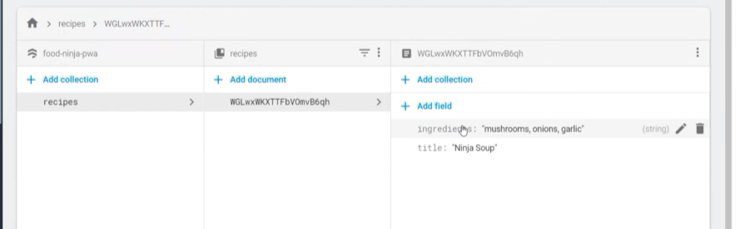

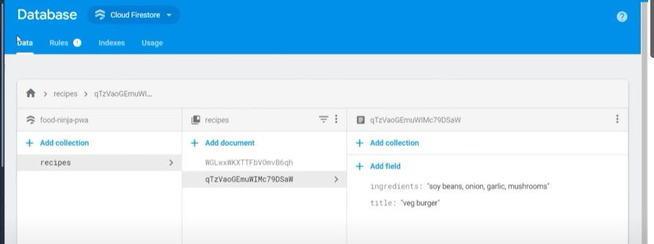Add another document (each one has unique id’s)

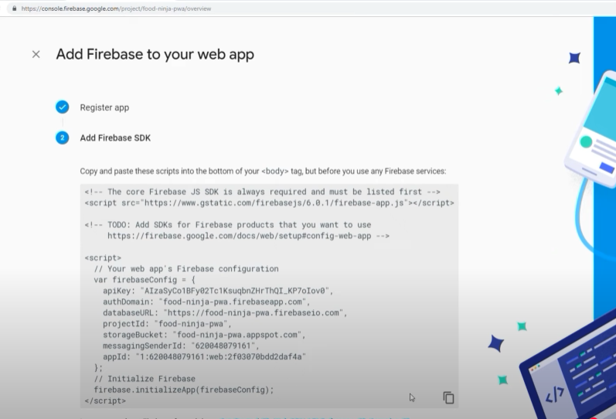

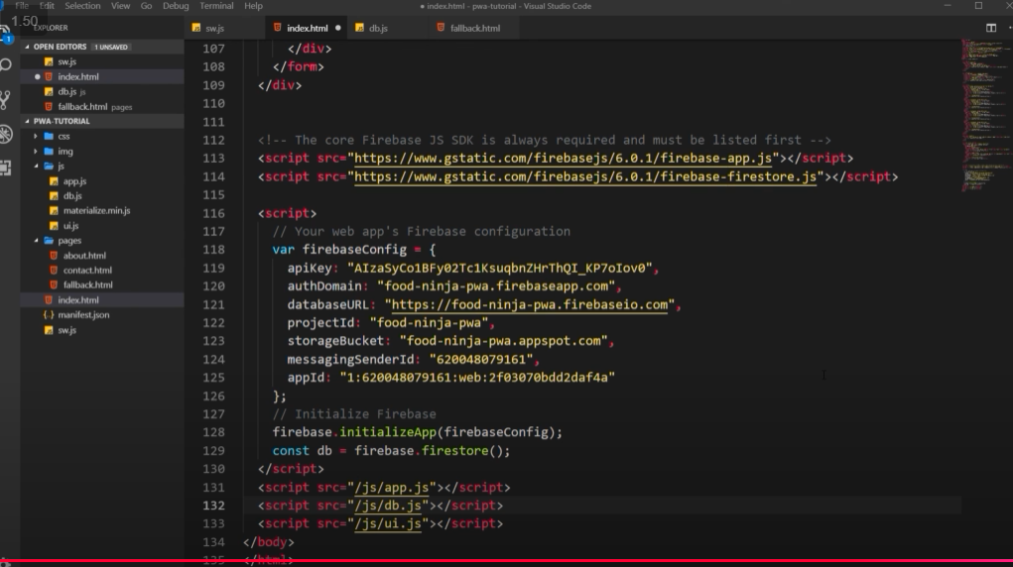

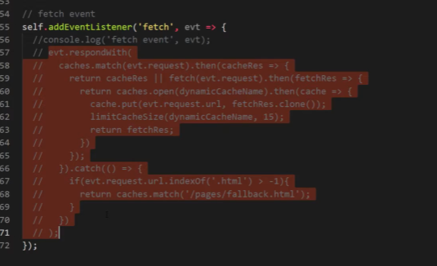Don’t cache different data requests for now!

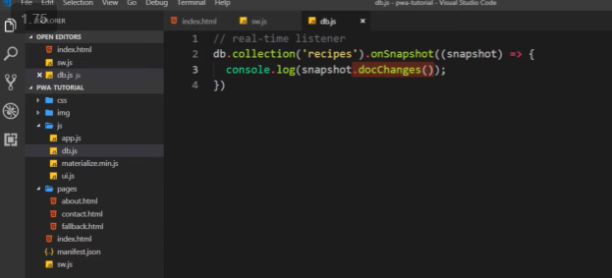

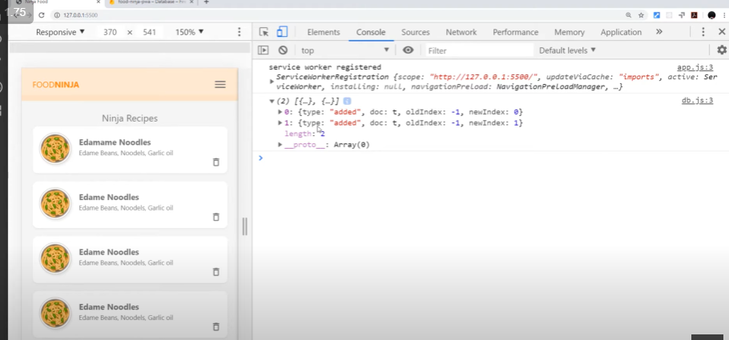

Evey time something changes in the recipes collection we get does changes back!  
works for added/changed ad removed.  
  
This is important because we want our database and UI to be synced together 🡪 which means when something is added or removed to the database it shall also be done in the UI.

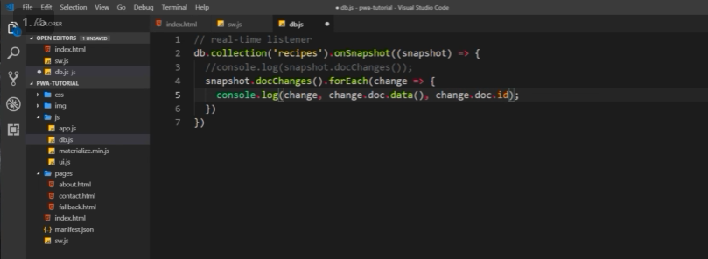

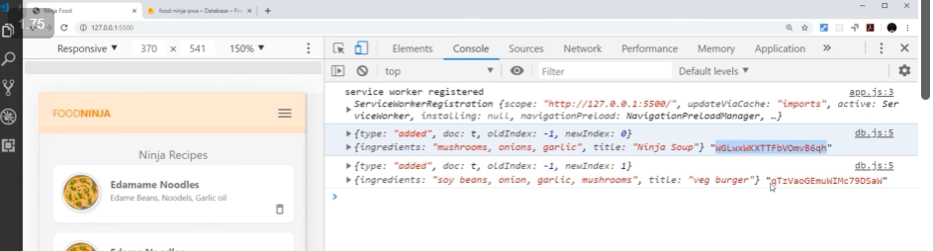

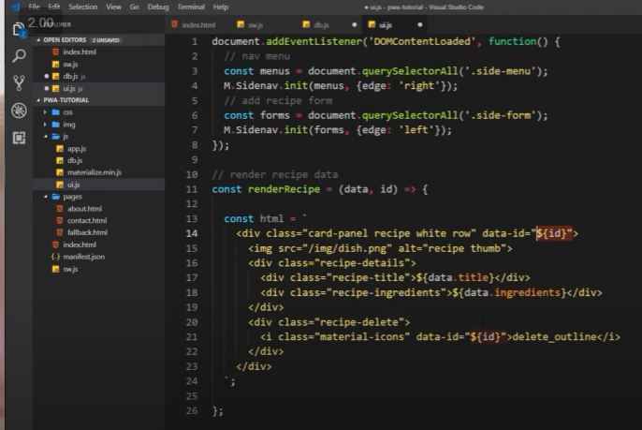

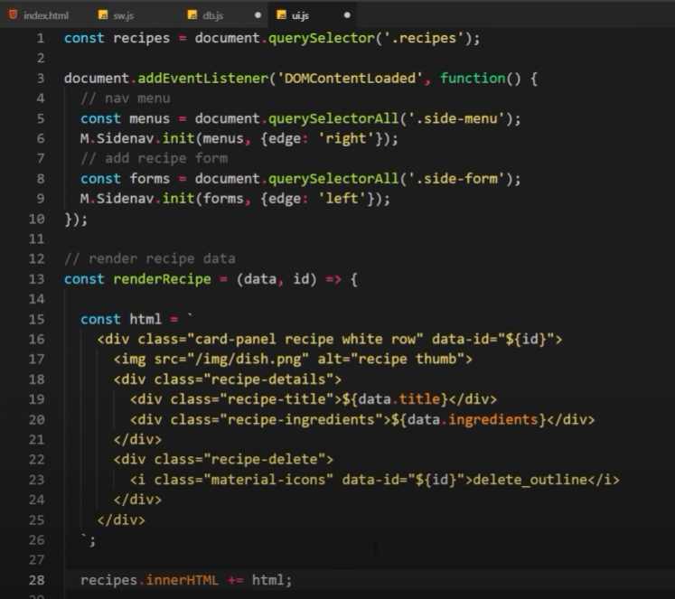

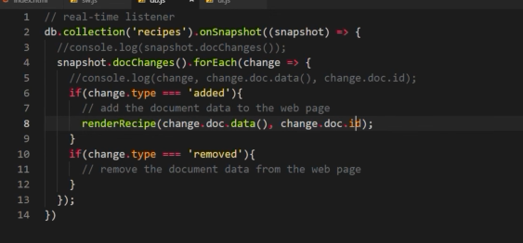

## Offline Data (Firestroe & indexedDB)

We don’t wan to cache data base responses using the service worker, because it is not the best way to deal with offfline data (we show old cached data)

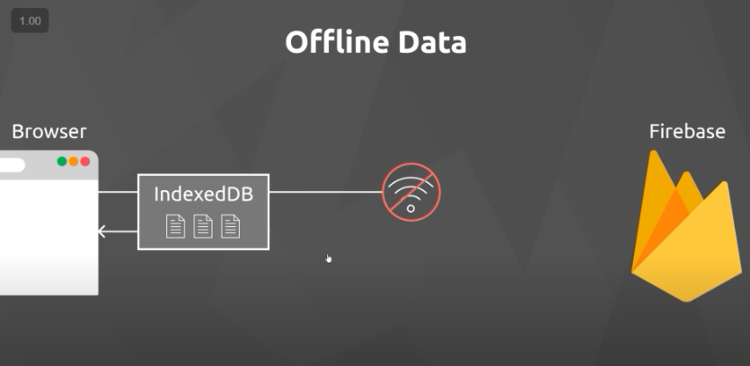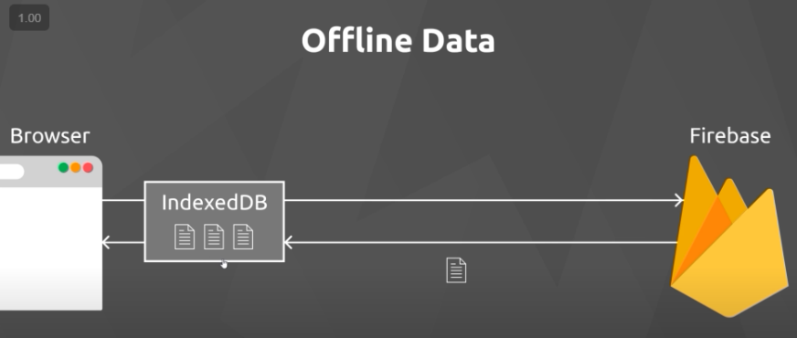

When user is offline and posts data, we first would store it in indexedDB and once the user is online again, we then store it in the database.  
Firestore manages IndexedDB for us in the background.

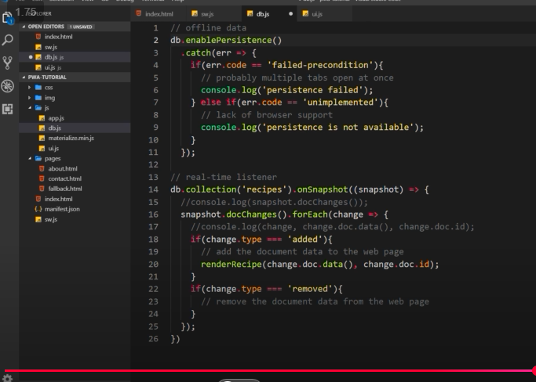We only have to do a bit of code to activate this functionality:

Only cache assets from fetch event if assets have nothing to do with the db!

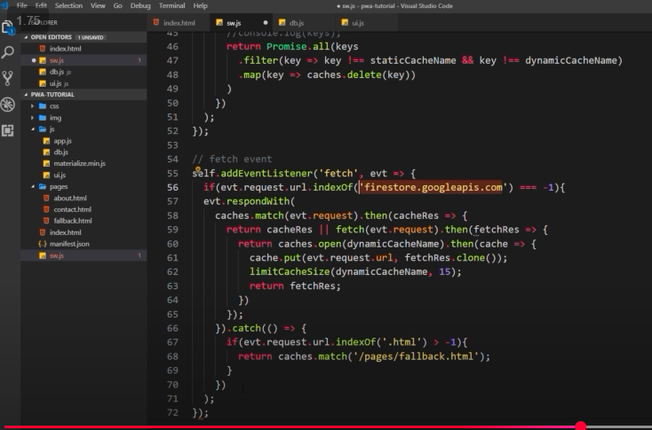

## **Adding new Documents**

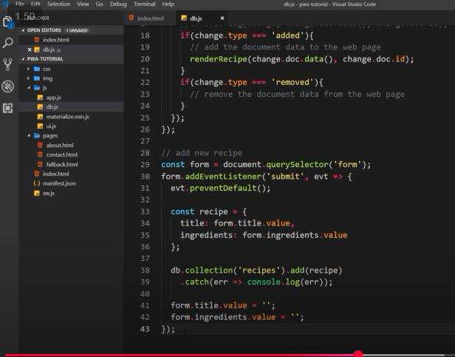

## **Removing Documents**

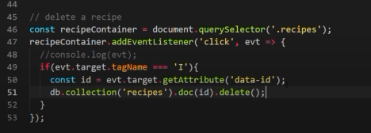Instead of adding event listener to each delete button use event delegation.  
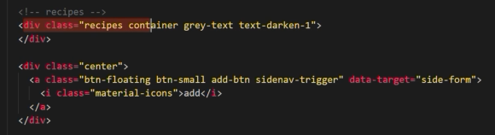

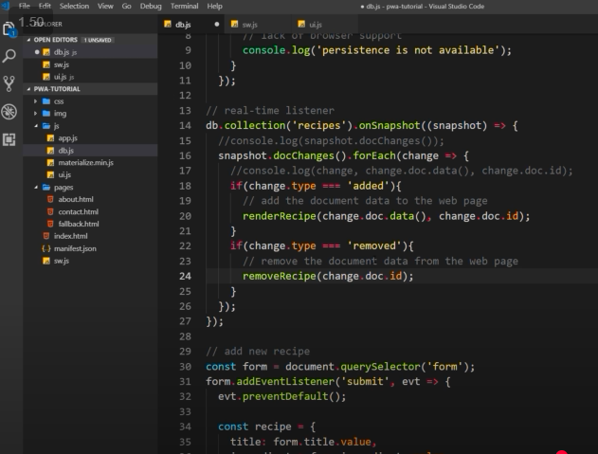

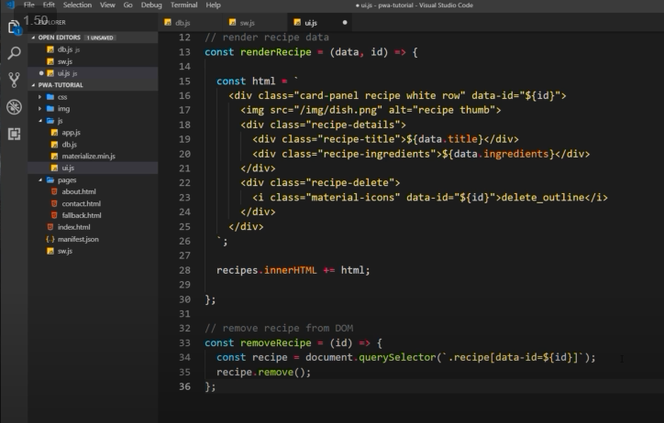

## **Deploying to Firebase**

You need node js to be installed on your computer.

